ASTRONOMY 100

Unit 5 Homework

1. List and describe/define the major functions of a telescope?

The light collecting power of an objective (principal mirror in a reflector, lens in a refractor) is a measure of how much light can be collected from distant objects by the objective. Specifically, it is proportional to the square of the aperture's diameter in nominal terms. By increasing the aperture by two stops, four times as much light is collected.
When it comes to photography, the term "resolving power" refers to the amount of detail that can be seen in a photograph. In terms of numerical value, it is proportionate to the diameter of the opening. Increasing the aperture by a factor of two leads in the resolution of features that are half the size, at the very least in theory.
When it comes to seeing via a telescope, magnification is not a natural characteristic of the instrument; rather, it is something that the instrument must be forced to perform in order to see anything through it. For better or worse, the picture generated by the telescope's optical train must be magnified in order for you to be able to perceive its fine features. As we'll learn later, there are upper and lower limitations to how much magnification you should employ visually, and you should avoid exceeding either.

2. What two different components of a telescope can be used to focus light?

Mirrors and lens

3. What major problem did the Hubble telescope originally have, and how was it corrected?
The Hubble Space Telescope was launched into low-Earth orbit in 1990 and is still in use today. NASA developed it with help from the European Space Agency. The optical system had a major problem, and investigation revealed that the reason was a primary mirror that had been polished to the incorrect form, producing spherical aberration. In 1993, a service mission was sent to install a set of specialist lenses to repair the telescope's damaged primary mirror. There have been a total of five astronaut servicing missions to Hubble.
4. Briefly describe the three types of telescopes (shape? Lens? Mirror? Both? Cost? Use?)
Refracting telescope - Lenses are used to collect light and concentrate it into a single point. It is used in spy glasses, serious astronomy and also long focus camera lens. It produces an upright image.
Newtonian telescope – This uses a mirror to focus light from distance objects. There are less expensive compared to the Refracting telescope.

Schmidt-Cassegrain Telescopes- This uses a series of mirrors, also, to concentrate the parallel rays of incoming light onto a convex secondary mirror, utilize a spherical primary mirror. The light is then reflected back to the eyepiece or detector through a hole in the main mirror.

5. What is the difference between good ‘seeing’ and good ‘transparency’? Give one condition for each.
Good seeing – this is a measure of atmospheric steadiness or how stable it is. Condition, moderate seeing, with larger air tremors.
Good transparency – this is opacity of the atmosphere or how clear it is on a given night. Condition,
6. Which of the seven types of EM spectra can survive the trip through our atmosphere and reach the ground (even if it is just partially)?
The atmosphere of the Earth is effectively penetrated by visible light also the FM and TV waves.
7. Which telescope can produce brighter images (gather more light)? A. 5” B. 6” C. 8”
C
8. If two stars are separated by only 0.85” (seconds of arc) in the sky, which of the following telescopes would only see one star (review the telescopes ppt)? One with a resolving power of: a. 0.50” b. 0.90” c. 0.85”
B
Short Answer / Essay Questions:
[The answer must include all relevant information, yet not include a lot of non-relevant information for full credit. Even though you will be referencing various resources, you need to compose your answer primarily in your own words. A completely (or heavily) copied response will also result in a deduction of points. A good rule of thumb would be to attempt to explain the question to a peer who has not taken your astronomy class.]

Answer in AT LEAST 5-7 complete sentences for full credit.

9. Why do we bother making space-based telescopes? Make sure to answer the main reason WHY. Include limitations of Earth-based telescopes and the advantages of space-based telescopes in your answer for full credit.
The primary reason we send telescopes into space is to bypass the Earth's atmosphere and gain a better view of the planets, stars, and galaxies we're investigating. Our atmosphere functions as a protective blanket, allowing only some wavelengths of light to get through while blocking others. The Earth's atmosphere absorbs a lot of the infrared and ultraviolet light that travels through it, so ground-based telescopes can't do the same. Another issue with ground-based telescopes is that they are vulnerable to local weather conditions, and thick clouds might obviate the possibility of making any worthwhile observations. Advantages of space-based telescope, As the atmosphere has no effect on it, clearer observations may be made. There is no distortion owing to twinkling, sky glow, or light pollution effects. Broader wavelengths of the electromagnetic spectrum, such as infrared, ultraviolet, x-rays, and gamma rays, may be seen.

10. Why is magnification NOT the most important consideration in purchasing a telescope? Make sure to include appropriate definitions and other considerations that are most important for full credit.
The light received by the scope is spread over a wider area, resulting in a fainter picture in the eyepiece. High magnification makes an item look larger, but the light obtained by the scope is distributed over a larger area, resulting in a fainter image in the eyepiece. Lower magnification power allows for a better viewing experience, especially when gazing at objects that are dispersed throughout the sky, like as clusters or nebulae. The aperture of a telescope is the most important measurement. The diameter of the lens at the top of the tube is measured by aperture with refractors. This is the light-collecting lens.

Define the following terms:
- light gathering power – is a telescope's ability to capture far more light than the human eye can.
- resolving power – capacity of an optical equipment or film type to separate or identify tiny or closely nearby pictures
- magnification – is really a connection between two separate optical systems.

- exit pupil - is a tiny circle in front of a telescope that all emerging light rays pass through
- refractor - is a sort of optical telescope that forms an image with the use of a lens as its objective.
- reflector - is a type of telescope that utilizes one or more curved mirrors to reflect light and produce a picture.
- Schmidt-Cassegrain - is a catadioptric telescope that combines the optical path of a Cassegrain reflector with a Schmidt corrector plate to produce a small astronomical instrument with simple spherical surfaces.
- Transparency - Clouds, dust, and haze determine how bright the sky is on any particular night.
- Seeing - refers to the deterioration of an astronomical object's appearance caused by turbulent airflows in Earth's atmosphere, which can be seen as blurring, sparkling, or fluctuating distortion.

ASTRONOMY 100

Unit 6 Homework

1. How many planets are there in the solar system (don’t count dwarf planets)?
a. 8 b. 9 c. 12 d. 13
a

2. What is the most abundant (non-observable) material in our galaxy?
Dark Matter
3. What are the two most abundant elements of the universe? (choose all that apply)
a. hydrogen b. helium c. carbon d. iron e. oxygen
a and b

4. What object (or objects) is (are) the second most massive component of the Solar System?
Jupiter
5. What are Dwarf Planets also known as?
plutoids

6. Type in at least four differences between the planets (I did one for you. You do four more. Use the text and my presentations to help you answer this question).

Inner Planets (Terrestrial) | Outer Planets (Jovian)
Close to each other  a. The inner planets are closer to the Sun and are smaller and rockier.  b. Mercury and Venus do not have moons,  c. The four inner planets have slower orbits, slower spin, no rings, and they are made of rock and metal  d. The gas giants and ice giants have weather but no rocky surface. | Far From each other  - The outer planets are further away, larger and made up mostly of gas.  b. Earth has one, and Mars has two  - c. The four outer planets have faster orbits and spins, a composition of gases and liquids, numerous moons, and rings.  d. The inner system rocky planets, are losing atmosphere which is swept off by the Solar Wind

7. What were planets typically named after?
Gods and goddesses from Greece and Rome
8. Where are the asteroids found? What is the shape of their orbits?
The asteroid is formed like a torus and is located between Jupiter and Mars' orbits.

9. Where are the comets found? What is the shape of their orbits?
The comet is shaped like an ellipse and is found in the Oort Cloud.
10. Which of the two objects (asteroids or comets) is mostly made of rock?
Asteroids
11. Which (asteroids or comets) is mostly made of ice?
Comets
12. What is the main thing that differentiates meteors and meteorites?
a. size b. location c. shape
13. What are meteor showers named after?
constellation
14. What were the main stages of the solar system formation theory? (List with a brief explanation of each)

15. What are the main methods of detecting exoplanets? (List them and briefly describe them)
transit method – When a planet passes between a star and its observer, this happens.
wobble method - is an indirect approach for detecting extrasolar planets and brown dwarfs using radial-velocity data by looking for Doppler changes in the planet's parent star's spectrum.

Define the following terms:

- Solar system - the sun, as well as the group of heavenly planets that are attracted to it and circle around it
- Asteroid - are actually small planets that can't be categorized as either planets or comets.
- Comet - a celestial object consisting of a nucleus of ice and dust and, when near the sun, a ‘tail’ of gas and dust particles pointing away from the sun.
- Ion tail - The long, narrow tail of a comet, often bluish in color, that is composed of ionized cometary material directed from a comet's nucleus radially away from the sun by the solar wind. Also called plasma tail.
- Dust tail - A relatively wide, often flaring and curved, illuminated tail composed of dust that is forced away from a comet's nucleus by solar radiation pressure.
- Exoplanet - also called exoplanet, any planetary body that is outside the solar system and that usually orbits a star other than the Sun
- Meteor - a small body of matter from outer space that enters the earth's atmosphere, becoming incandescent as a result of friction and appearing as a streak of light
- Meteorite - a piece of rock or metal that has fallen to the earth's surface from outer space as a meteor. Over 90 per cent of meteorites are of rock while the remainder consist wholly or partly of iron and nickel.
- Meteoroid - significantly smaller than asteroids, and range in size from small grains to one-meter-wide objects.

Use the planetary data grid to answer the following 7 questions:
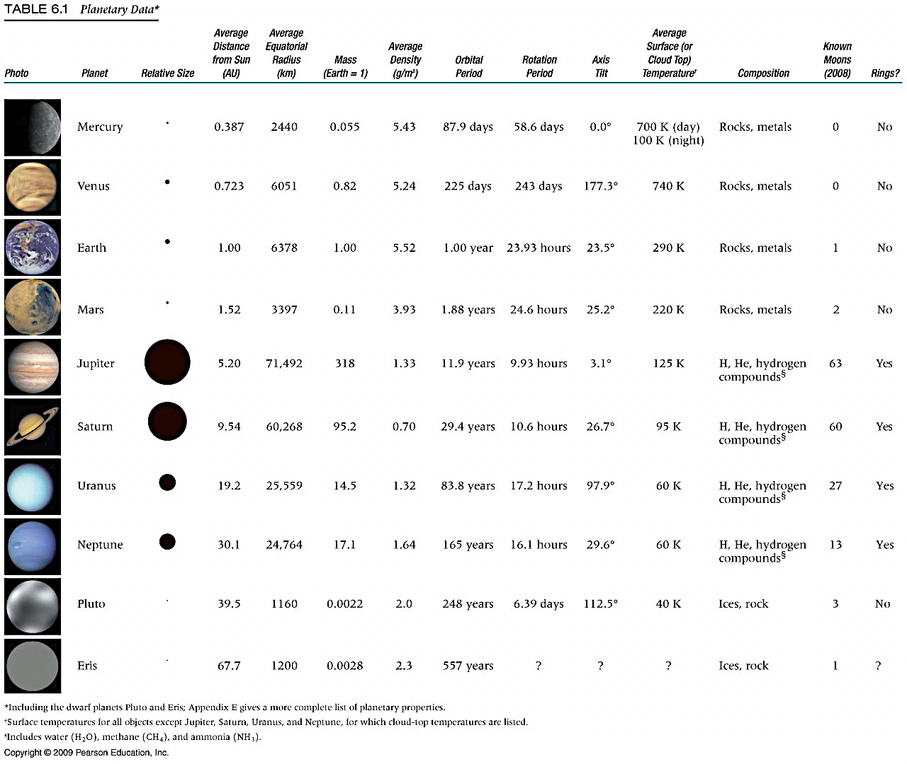

16. List the 5 terrestrial worlds (include the moon) in order from smallest to largest.
Moon
Mercury
Mars
Venus
Earth
17. Which of the inner planets gets the HOTTEST?
a. Mercury b. Venus c. Earth d. Mars
B
18. Which planet is most like the Earth in size?
a. Mercury b. Venus
B
19. Which planet has nearly the same length Day as Earth?
a. Mercury b. Venus c. Mars d. Jupiter
C
20. Which planet will celebrate only ONE year in the same amount of time the average human lives their ENTIRE life? a. Mercury b. Venus c. Mars d. Jupiter e. Saturn f. Uranus g. Neptune
A
21. What pattern do you notice about average distance from the Sun, and length of year?
A. longer year B. shorter year C. no pattern
C
22. What pattern do you notice about size of planet and length of day?
A. longer day B. shorter day C. no pattern
A
Short Answer / Essay Questions:

[The answer must include all relevant information, yet not include a lot of non-relevant information for full credit. Even though you will be referencing various resources, you need to compose your answer primarily in your own words. A completely (or heavily) copied response will also result in a deduction of points. A good rule of thumb would be to attempt to explain the question to a peer who has not taken your astronomy class.]

Answer in AT LEAST 5-7 complete sentences for full credit.

23. Contrast the formation of the atmospheres between the inner and outer planets. Make sure to include identifying features of each for full credit.

Terrestrial planets have a large amount of heavier gases and gaseous compounds, including carbon dioxide, nitrogen, oxygen, ozone, and argon, among other things. The atmospheres of gas giants, on the other hand, are mostly comprised of hydrogen and helium. Since the formation of the planets, the atmospheres of at least the inner planets have changed. The inner planets are smaller and more rockier than the outer planets because they are closer to the Sun. The outer planets are further distant, bigger, and primarily composed of gaseous material. Mercury, Venus, Earth, and Mars are the inner planets, and they are arranged in descending order of distance from the sun, from closest to furthest.

24. What is a NEO, and why should we be concerned about them? Fully define a NEO, processes, and consequences for full credit.

A near-Earth object (NEO) is any small Solar System body whose orbit brings it into proximity with Earth. By convention, a Solar System body is a NEO if its closest approach to the Sun (perihelion) is less than 1.3 astronomical units (AU). ... Most known PHOs and NEOs are asteroids, but a small fraction are comets. Statistically, the greatest danger is from an NEO with about 1 million megatons energy (roughly 2 km in diameter). On average, one of these collides with the Earth once or twice per million years, producing a global catastrophe that would kill a substantial (but unknown) fraction of the Earth's human population.

25. What are the differences between the two tails of a comet? Describe the differences and why there are differences.

Comets have two tails because escaping gas and dust are influenced by the Sun in slightly different ways, and the tails point in slightly different directions. Gases escaping from the comet are ionized by the ultraviolet photons from the Sun. The ion tail forms from the volatile gases in the coma when they are ionized by… …from the Sun, and the dust (Type II) tails coming from solar radiation pressure on the fine dust particles emitted from the comet.

ASTRONOMY 100

Unit 7 Homework

1. What are the two main heat (energy) transport regions of the sun?

__________________photosphere_____________ and ____________________________Atmosphere____

2. In which of these regions does energy take millions of years to traverse? ___the core_________________

3. What are the two main regions of the Sun’s atmosphere?

______ corona (top)_________________________ and _ chromosphere (bottom)._______________________________
4. What are the two possible outcomes if the Sun does not maintain hydrostatic equilibrium?
The tendency of gravity is to compress the Sun. If the Sun were to collapse inward under its own gravity, it would crunch down to a black hole in the course of a few hours. Obviously, such a catastrophe hasn't happened
5. List the layers of the Sun inward, in order, from Corona to Core.
The corona,transition region,chromosphere,photosphere,convection zone,radiative zone,core.
6. What are three features of the Sun that the Sun’s strong magnetic field is responsible for?
Solar prominences, filaments, and coronal loops are structures formed from plasma suspended by magnetic fields in the Sun's atmosphere. Voids called coronal holes sometimes appear in the solar atmosphere, allowing fast streams of solar wind to flow freely outward into space.

Short Answer / Essay Questions:

[The answer must include all relevant information, yet not include a lot of non-relevant information for full credit. Even though you will be referencing various resources, you need to compose your answer primarily in your own words. A completely (or heavily) copied response will also result in a deduction of points. A good rule of thumb would be to attempt to explain the question to a peer who has not taken your astronomy class.]

Answer in AT LEAST 5-7 complete sentences for full credit.

7. Explain the phrase (in at least 3 sentences) “The Sun generates energy at the expense of consuming itself.” Describe how the Sun generates energy, and clearly explain the phrase for full credit. You will likely do better if you try to explain in your own words.
The Sun generates energy at the expense of consuming itself. The Sun needs hydrogen and helium to create energy. However, the energy from these two gasses are what produces heat. Therefore, the Sun must consume itself in order to create energy and heat. During nuclear fusion, the high pressure and temperature in the sun's core cause nuclei to separate from their electrons. Hydrogen nuclei fuse to form one helium atom. During the fusion process, radiant energy is released. The sun's energy comes from within the sun itself. ... The sun generates energy from a process called nuclear fusion.

8. Why are sunspots cooler than their surrounding regions? Make sure to define sunspots, the process of sunspot formation, and the process required for the temperature difference for full credit.
Sunspots a spot or patch that appears from time to time on the sun's surface, appearing dark by contrast with its surroundings. It is accepted that sunspots occur when a magnetic flux tube rises above the photosphere, forming a pair of positive and negative spots at the cross–sections. However, this model has at least three long–standing problems, which contradict with the model, but have been left behind for a long time.

Define the following terms:

- hydrostatic equilibrium – In fluid mechanics, hydrostatic equilibrium or hydrostatic balance (also known as hydrostasy) is the condition of a fluid or plastic solid at rest.
- granule – a small particle especially : one of numerous particles forming a larger unit. 2 : any of the small short-lived brilliant spots on the sun's photosphere.
- granulation – That part of the healing process in which lumpy, pink tissue containing new connective tissue and capillaries forms around the edges of a wound. Granulation of a wound is normal and desirable.
- photosphere – or sphere of light, is the level of the solar atmosphere from which we get our light and heat, and it is the part that we can see with our eyes.
- chromosphere – a reddish gaseous layer immediately above the photosphere of the sun or another star which, together with the corona, constitutes its outer atmosphere.

- radiative (radiation) zone – A radiation zone, or radiative region is a layer of a star's interior where energy is primarily transported toward the exterior by means of radiative diffusion and thermal conduction, rather than by convection. Energy travels through the radiation zone in the form of electromagnetic radiation as photons.
- core – the central, innermost, or most essential part of anything. Also called magnetic core. Electricity. the piece of iron, bundle of iron wires, or other ferrous material forming the central or inner portion in an electromagnet, induction coil, transformer, or the like. (in mining, geology, etc.)
- corona – The corona is the outer atmosphere of the Sun. It extends many thousands of kilometers (miles) above the visible "surface" of the Sun,
- chromosphere – The lower region of the Sun's atmosphere is called the chromosphere. Its name comes from the Greek root chroma (meaning color), for it appears bright red when viewed during a solar eclipse. The chromosphere extends for about 2,000 kilometers (1,200 miles) above the visible surface of the Sun.
convection zone – The convection zone is the outer-most layer of the interior. It extends from a depth of 200,000 km up to the visible surface of the Sun. Energy is transported by convection in this region. The surface of the convection zone is where light (photons) is created.

- prominence – A solar prominence (also known as a filament when viewed against the solar disk) is a large, bright feature extending outward from the Sun's surface. Prominences are anchored to the Sun's surface in the photosphere, and extend outwards into the Sun's hot outer atmosphere, called the corona
- solar flare – A solar flare is a sudden flash of increased brightness on the Sun, usually observed near its surface and in close proximity to a sunspot group. ... Flares are closely associated with the ejection of plasmas and particles through the Sun's corona into outer space; flares also copiously emit radio waves.

ASTRONOMY 100

Unit 8 Homework

- What properties of stars does the spectral type describe?
To those who can read its meaning, the spectral code tells at a glance just what kind of object the star really is: its color, size, and luminosity compared to the Sun and stars of all other types; its peculiarities, its history, and its future.

- What properties of stars are plotted on the H-R diagram?
- Developed independently in the early 1900s by Ejnar Hertzsprung and Henry Norris Russell, it plots the temperature of stars against their luminosity (the theoretical HR diagram), or the colour of stars (or spectral type) against their absolute magnitude (the observational HR diagram, also known as a colour-magnitude .

- Which stars age faster? High mass or low mass?

Massive stars evolve quicker than light stars. In the previous chapter, the relationship between the luminosity and mass was explained using basic principles of how compressed gases behave.

High mass
- Which luminosity class represents stars that are still fusing hydrogen into helium?
Main-sequence stars are fusing hydrogen into helium in their cores, like the Sun. Luminous main-sequence stars are hot (blue). Less luminous ones are cooler (yellow or red).

5. Which star is brighter? Mag +3 or Mag +10?
Sirius
The brightest star in the night sky is Sirius, also known as the “Dog Star,” and the best time to see it is upon us!

- What are the spectral types in order (from coolest to hottest)?
In general, a star's temperature determines its color, from red to blue-white. Spectral types are named with a letter. The seven main types are M, K, G, F, A, B and O. M stars are the coldest stars and O stars are the hottest. The full system contains other types that are hard to find: W, R, N, and S.

7. What are the three main luminosity classes?
Bright Giants,
Giants
subGiants

8. What are the four main groups on the HR diagram? What is a property of each?
The Supergiants are cool stars, which are very large and very bright. They are located towards the top right of the graph
The Giants are cool stars, which are a little smaller and dimmer than the Supergiants
The White Dwarfs are very hot stars, which are small in size and relatively dim. They are found in the lower left of the H-R Diagram.
The Main Sequence is a band of stars, which includes most of the stars, like our Sun. These are usually smaller stars, often dwarf stars.
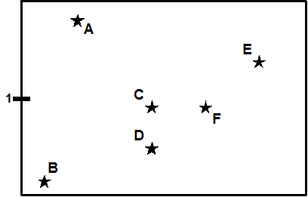
Use the following H-R Diagram to answer the following questions (you may want to review how to read an H-R diagram first)

9. Which is the hottest? A) Star B B) Star E C) Star D
B
10. Which star is larger (C or D)?

A) C B) D C) Neither. They are the same size
C

11. Star C is __C_____ star D. A) hotter than B) the same temperature as C) cooler than

12. Stars C and F share the same A) temp. B) size C) nothing
A

13. Which pair of stars have the same luminosity (brightness)? A) C & F B) C & D C) A & C
C
Draw and label each of the stars below (in questions 14-16) on the HR diagram above (or copy a picture to your homework).

You will have to label the vertical and horizontal axis as in your book or presentations. Answer the following questions using your drawings:

14. Which is brighter? A) B2V or B) G2V
A
15. Which is brighter? A) K5V or B) G2III
A
16. Which is larger? A) B6V or B) M3I
B
Short Answer / Essay Questions:

[The answer must include all relevant information, yet not include a lot of non-relevant information for full credit. Even though you will be referencing various resources, you need to compose your answer primarily in your own words. A completely (or heavily) copied response will also result in a deduction of points. A good rule of thumb would be to attempt to explain the question to a peer who has not taken your astronomy class.]

Answer in AT LEAST 5-7 complete sentences for full credit.

17. What is the difference between luminosity and apparent brightness? Give a real-world example to explain it to someone who is not in the class.
The apparent brightness is how much energy per square meter per second is coming from the star, as measured on Earth. Luminosity is the total energy radiated per second - measured in watts. Luminosity is the rate at which a star radiates energy into space. Apparent brightness is the rate at which a star's radiated energy reaches an observer on Earth. Apparent brightness depends on both luminosity and distance. If you put an automobile headlight 10 feet away and a flashlight 10 feet away, the flashlight will appear fainter because its luminosity is smaller. Stars have a wide range of apparent brightness measured here on Earth.

Define the following terms:

- apparent brightness – is the measure of the luminosity (a fancy word for actual brightness) of a star as seen from Earth.
- luminosity – the intrinsic brightness of a celestial object (as distinct from its apparent brightness diminished by distance).
- H-R diagram – is a graphical tool that astronomers use to classify stars according to their luminosity, spectral type, color, temperature and evolutionary stage
- Main sequence – a series of types to which most stars belong, represented on a Hertzsprung–Russell diagram as a continuous band extending from the upper left (hot, bright stars) to the lower right (cool, dim stars).
- Supergiants – a very large star that is even brighter than a giant, often despite being relatively cool.
- Giants – a star of relatively great size and luminosity compared to ordinary stars of the main sequence, and 10–100 times the diameter of the sun.
- White dwarfs – a small very dense star that is typically the size of a planet. A white dwarf is formed when a low-mass star has exhausted all its central nuclear fuel and lost its outer layers as a planetary nebula.
- Black hole – a region of space having a gravitational field so intense that no matter or radiation can escape.
- Neutron star – a celestial object of very small radius (typically 30 km) and very high density, composed predominantly of closely packed neutrons. Neutron stars are thought to form by the gravitational collapse of the remnant of a massive star after a supernova explosion, provided that the star is insufficiently massive to produce a black hole.
- Spectral type - the group in which a star is classified according to its spectrum, especially using the Harvard classification.
- Luminosity class - a classification of stars of a given spectral type according to their luminosity, breaking them down into dwarfs, giants, and supergiants.

ASTRONOMY 100

Unit 9 Homework

Fill in the blanks (please type or write your answer in a different color or in Bold):

Stellar evolution

______________Gravity_ holds stars together; ____ pressure of its gases supports _____________ supports stars against gravity.

______Gravity_________ and ___Pressure________ forces must balance.

______Pressure________ is created by _____high_____ _temperature______________ in a star’s core.

_____________High temperature _____________ cause _____heat_________ to flow from the core to the surface,

where it escapes into space as the star’s ___________luminosity_________ (starlight).

Escaping ____heat_______ is replenished by _____nuclear_____ ____fusion_________ in the core. (Hydrogen

Fuses to helium initially). The star eventually runs out of ____fuel______.

Lo-mass stars (M < 10 solar masses) turn into ________white dwarf________________. High

Mass stars (M > 10 solar masses) explode, leaving a _________neutron____ _____star_________ or

_____black________ _____holes_________.

Word Bank (you may use a word more than once)

fuel, black, heat, high, pressure, white, temperature, hole, gravity, fusion, luminosity, neutron, dwarf, nuclear, star

Short Answer / Essay Questions:

[The answer must include all relevant information, yet not include a lot of non-relevant information for full credit. Even though you will be referencing various resources, you need to compose your answer primarily in your own words. A completely (or heavily) copied response will also result in a deduction of points. A good rule of thumb would be to attempt to explain the question to a peer who has not taken your astronomy class.]

Answer in AT LEAST 5-7 complete sentences for full credit.

- Why do high mass stars age faster than low mass stars? Make sure to answer why with definitions and processes for full credit.
Massive stars have shorter lifetimes than ordinary tiny stars because, despite the fact that they contain a bigger amount of hydrogen for nuclear reactions, the pace at which they use their fuel is significantly higher than that of the common small star. High mass stars blue, blue-white, or white stars are the biggest, hottest, and brightest Main Sequence stars while Low-mass stars burn through their hydrogen fuel relatively slowly, allowing them to survive for a very long time

- Imagine plotting all the stars of a particular globular clusters on an HR diagram. Note that all stars in a particular cluster form around the same time. Describe a few ways that we can determine the relative ages of each cluster using an HR diagram. [Hint: use your ppt presentations to help you answer this question. Think of the turnoff point in section 22.3.]

By determining the mass of the main-sequence turnoff stars, we get the age of the cluster. The cluster age equals the main-sequence lifetime of the turnoff stars. This is one of the ways we have studied the age of the Universe and the formation history of the Galaxy. By placing the stars in a globular cluster on a Hertzprung-Russell diagram, astronomers can determine the cluster's age by looking at the main sequence turnoff point and comparing it with models of stellar evolution. Q: The globular cluster NGC 6397 is 7,800 light-years away.

Define the following terms:

- Main sequence – a series of types to which most stars belong, represented on a Hertzsprung–Russell diagram as a continuous band extending from the upper left (hot, bright stars) to the lower right (cool, dim stars).
- Supergiants – a very large star that is even brighter than a giant, often despite being relatively cool.
- Giants – a star of relatively great size and luminosity compared to ordinary stars of the main sequence, and 10–100 times the diameter of the sun.
- White dwarfs – a small very dense star that is typically the size of a planet. A white dwarf is formed when a low-mass star has exhausted all its central nuclear fuel and lost its outer layers as a planetary nebula
- Black hole – a region of space having a gravitational field so intense that no matter or radiation can escape.
- Neutron star – a celestial object of very small radius (typically 30 km) and very high density, composed predominantly of closely packed neutrons
- Nebula Theory (Solar Nebula Hypothesis) - is the most widely accepted model in the field of cosmogony to explain the formation and evolution of the Solar System

